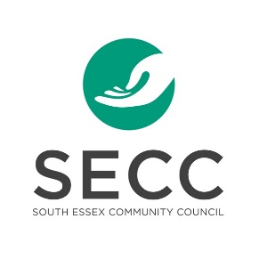
South Essex Community Council
Community Change Maker Scholarship

South Essex Community Council has been providing community services in Leamington, Kingsville and Wheatley since 1973. Every day, we strive to achieve our mission: “Helping people. Improving lives.” Although we’ve been doing community work for many years, we need the help of businesses, volunteers, and various community partners to accomplish our goals. SECC also believes that we must play an integral part in grooming and supporting the next generation of community change makers. We need your help to ensure our communities are vibrant, strong and thriving, not just for this generation, but also for the next.
The goal of the SECC Community Change Maker Scholarship is to provide financial support through a $500 scholarship to 4 young people who are planning to use their post-secondary educations to make societal change in the wider community, in the Province or in the world.
DEADLINE:
May 28, 2021, 5:00 pm
Applications must be submitted via email or in person to:
Carolyn Warkentin
Executive Director
South Essex Community Council
215 Talbot Street East, Leamington, ON
cwarkentin@secc.on.ca

What is a change maker? Some might describe a change maker as an innovator, an activist or a visionary. Change makers are driven by values and a mission. They seek to make meaningful change for a purpose. Change makers work with others to get things done. They develop creative solutions by venturing out of their comfort zones and they understand the value of being proactive. They know how to initiate collective action for good.

ELIGIBLE APPLICANTS:
- Students currently enrolled as a Grade 12 student at Kingsville District High School, Leamington District Secondary School, Cardinal Carter Secondary School or UMEI Christian High School
- Must have received an acceptance to begin studies at a post-secondary institution (college or university)
- Are actively making change for good in their school, neighbourhood or community.

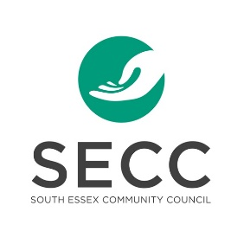
SECC Community Change Maker Scholarship
APPLICATION
- PERSONAL INFORMATION
Name:

Address:

Phone Number: | Email:
Name of Current High School:

Name of Post-Secondary Institution you plan to attend:

Please indicate your field of study:

- ESSAY
Please tell us about yourself and how you have strived to make a positive difference in your school, community or neighbourhood. Use the following questions as a guide to write your essay. Your essay should be no longer than 500 words.
- Why do you want to go into your stated field of study?
- How do you plan to use your education to make a difference in your community or in the world?
- What are you currently doing to make positive change in your school or in your neighbourhood?
- Why do you think you are a good candidate for the SECC Community Changemaker Scholarship?
- Are there people in your life who have influenced you to pursue your chosen field of study? How did they influence you?
- How are you a change maker?

- REFERENCES
Please provide 2 letters of reference with your application. One should be from a teacher and one should be from a member of the community.
- STATEMENT OF ACCURACY I hereby affirm that all the above stated information provided by me is true and correct to the best of my knowledge. I also consent that my picture may be taken and used for any purpose deemed necessary to promote SECC’s Community Change Maker Scholarship Program.

Signature of scholarship applicant: _______________________________________Date: ______________________

